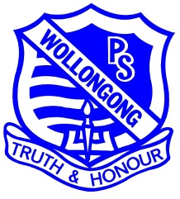 | WOLLONGONG PUBLIC SCHOOL  Church Street, Wollongong 2500 Phone: 4228 9120 Fax: 4226 5091  Wollongong-p.school@det.nsw.edu.au  Principal: Mr Harold Cosier
Friday 8 February 2018
Stage 3 BYOD Program
Dear Parents and Carers,

We are really looking forward to the exciting times ahead with the BYOD program for our Stage 3 Students, and hope you are having a conversation with your child about their responsibilities. As a school we have decided to purchase iPads to support student learning. We understand this may not suit everyone so in 2018 our Stage 3 BYOD program will allow students to bring any device. We are however, encouraging families who are buying a new device to choose an iPad with the aim to move towards a ‘Locked Down Model’ where iPads are the device used at school in 2019. This will assist us as we can focus on student and staff skills, troubleshooting and technological capabilities around one sort of device.

When purchasing an iPad, please consider the following specifications:
Suggested Model: iPad 9.7 (Cheapest base model) or above
Operating System: IOS 10 or above
Memory: 32 gig or above
Wireless: Built in Wi-Fi
Additional: Case that is tough and sturdy with a Keyboard attached

If you are choosing a different device, please consider the following specifications:
Performance: Look for, Intel Core™ i3, Core™ i5 and Core™ i7 in Windows machines
Memory: At least 128GB of storage in laptops, ultra books and two-in-ones
Wireless: Make sure it has 2.4Ghz or 5Ghz dual band wireless to access the school network
Additional: Case that is tough
Size: Lightweight- Aim for under 1.5kg
Battery: Make sure it lasts a 6-hour school day and look for a modern processor to extend this

Outlined below are some procedural aspects to ensure that safety of the devices is maintained and we have a successful program. The students will be well rehearsed in school procedures as guided by the BYOD policy and children have ben learning about their responsibilities already this year. Before students can BYOD, they must read, sign and return the student charter. We anticipate devices coming into the classroom from Wednesday 14th February. If you are un able to supply a device students will have access to school owned iPads and are still required to sign the charter.

Some of the information below relates directly to iPads but can be applied to various devices. Please review these points and help us by ensuring children are set up to use the device at school for school purposes.

Messages
Most devices have the ability to send messages from device to device once connected to WIFI. This is definitely not allowed during school time and we would like your support to ensure it doesn’t happen from home either. I am sure you can appreciate the issues that may arise with this so I have included a step by step guide on how to turn off the option on an iPad below. Please remind students that this is outside of the Student Charter and consequences will be applied if necessary.

Shared Device
If your child is using a device that is shared at home it would be appreciated if you could create a folder on the device for the ‘Required Applications’ that we need for school. We can then monitor what Applications the students are using more efficiently and children will be able to begin their work quickly.

Troubleshooting
Please be patient as we begin, giving us time to help children learn about managing their device and connecting to the school Wifi. We will be training students as Techsperts as they often develop the expertise to resolve issues faster than adults. Initially this will take some time but we hope we can troubleshoot problems quickly as they arise.

Apps
This is dependent on the device you have but we will aim to use Applications that are accessible over various devices. The Apps listed below are for an Ipad. Some may be available on other devices or we recommend using Google to find a similar App. These Apps are able to be used across all Key Learning Areas which will enable staff and students to become proficient at using the technology quickly which will ensure that the focus will remain on learning.

Free Apps |  | Please Purchase
QR reader | 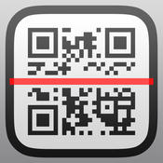 | Popplet
Chrome |  | Book creator
Dictionary |  | Pic Collage
Google Classroom |  | Explain Everything
Google Slides |  | Google Sheets | 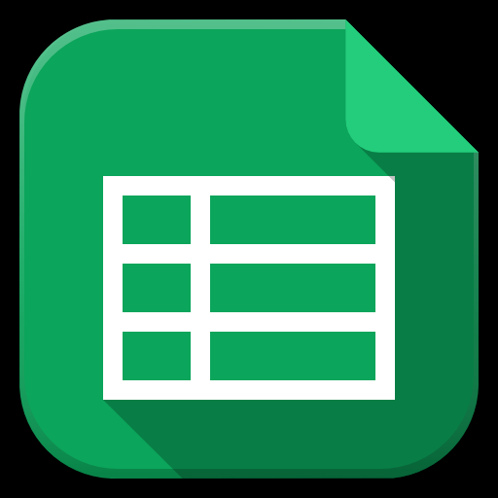
Google Sites | 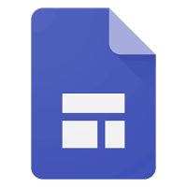 | Number Pieces
Find iPhone | 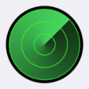 | iMovie
Calculator |  | Google Drive
Google Docs | 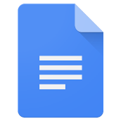 | Google Sheets | 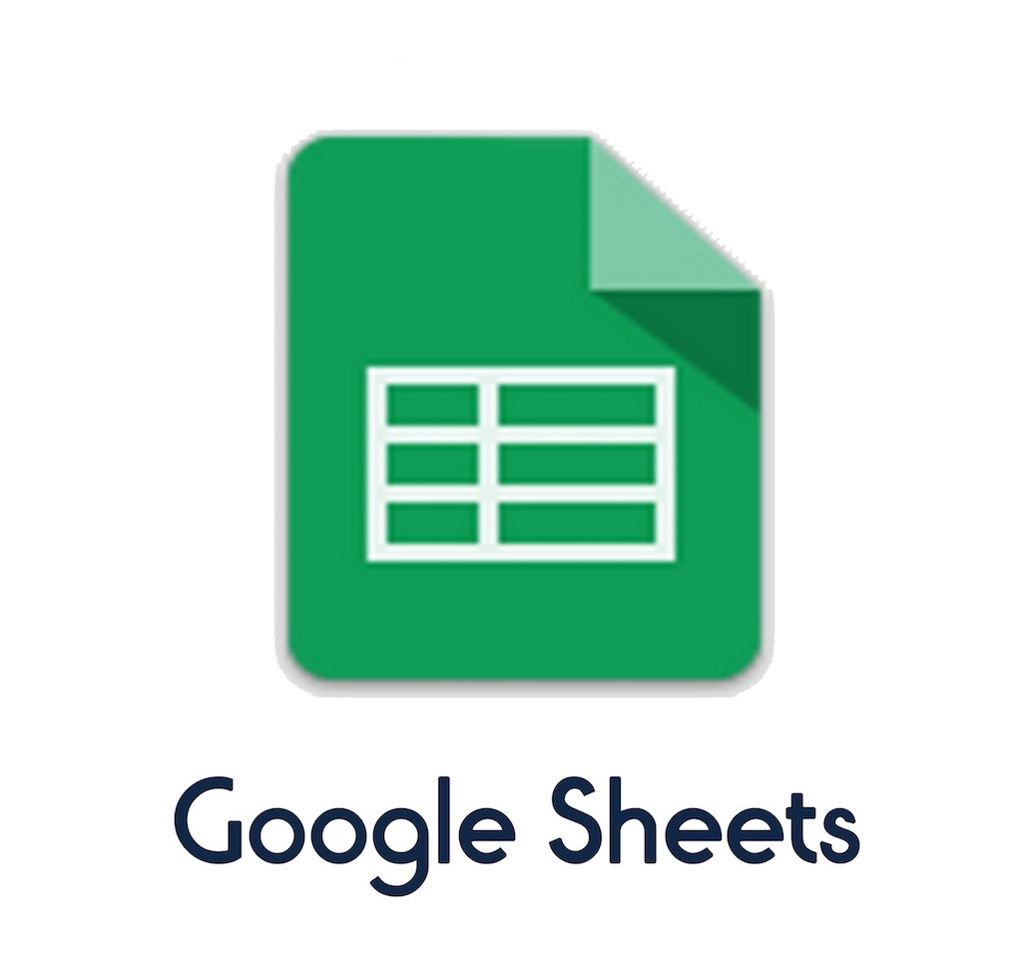

Please read through the BYOD charter with your child and discuss their responsibilities to help ensure success. We look forward to empowering your child and enhancing their learning opportunities throughout the year. If you have any concerns, please email me at matt.richards5@det.nsw.edu.au.

Kind Regards,

Matt Richards
Stage 3
Assistant Principal
Step by Step Guide to Turn off Messages on iPad
In the Settings app on your iPad, if you select Messages on the left, you will see several options on the right. The first one is an on/off switch. If you turn that off, new texts will not appear on your iPad. When you want to start seeing texts again, just turn the switch on.
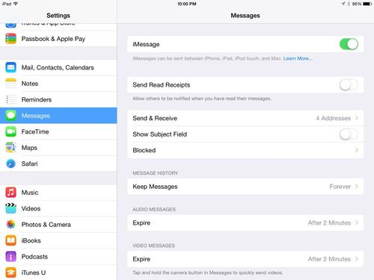

Another solution is to sign out of your iMessages account. To do so, once again open the Settings app and go to Messages, but this time tap the Send & Receive option. On the next screen, your Apple ID is shown at the top — tap it. This brings up a window that gives you four options, the last option of which is Sign Out. Once you select this, your iPad will stop receiving messages, and the only way that anyone can get them to start showing up again is to log back in using your Apple ID username and password — and when they do so, you will get alerts on your other devices, such as your iPhone, that your iPad is now using your account to get messages.

Note, however, that anyone with access to your iPad can still open your Messages app and read your old texts, even if you have stopped new texts from coming in. If you don't want that to happen, go to the Messages app, tap Edit at the top left, and then select each of your prior conversations and then tap delete at the bottom. In my tests, this only deleted conversations on the iPad and did not also delete the conversations on my iPhone.

